Ayrton Bayer Date: 05/29/19

2016 Stock Forecast results:

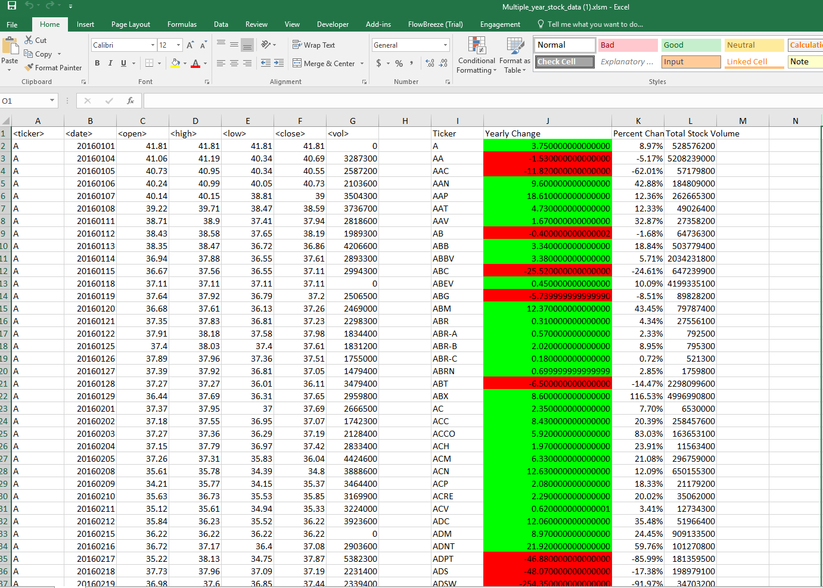

2015 Stock Forecast results:

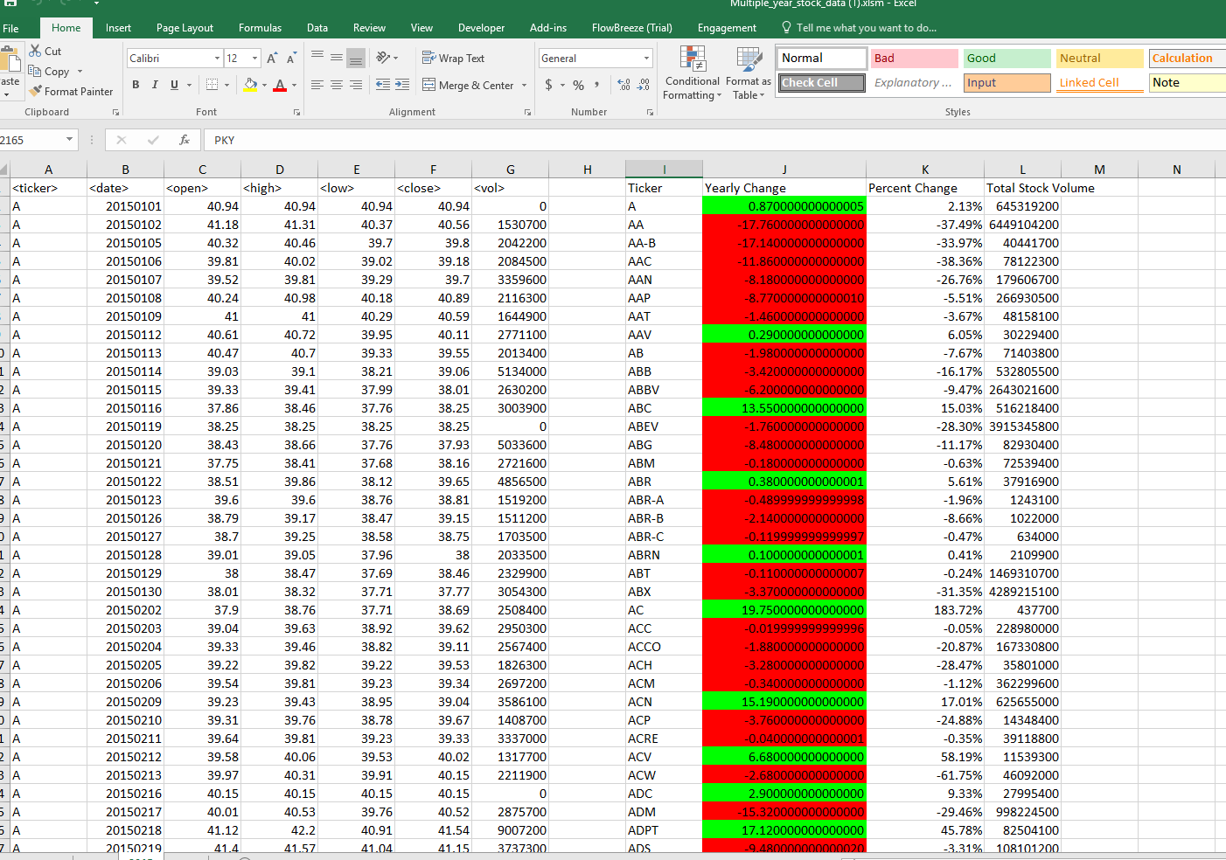

2014 Stock Forecast results:

